**МІНІСТЕРСТО ОСВІТИ І НАУКИ УКРАЇНИ**

**НАЦІОНАЛЬНИЙ УНІВЕРСИТЕТ “ЛЬВІВСЬКА ПОЛІТЕХНІКА”**



**Кафедра ЕОМ**

**Лабораторної роботи №3**

**з дисципліни**

**«Моделювання комп’ютерних систем»**

**Варіант 9**

**Виконав:**

Студент гр КІ-201

Гординяк В. Р.

**Перевірив:**

Козак Н. Б.

Львів – 2023

**Тема роботи**. Поведінковий опис цифрового автомата. Перевірка роботи автомата за допомогою **Elbert V2 – Spartan 3A FPGA**.

**Мета роботи**. На базі стенда реалізувати цифровий автомат для обчислення значення виразу дотримуючись наступних вимог.

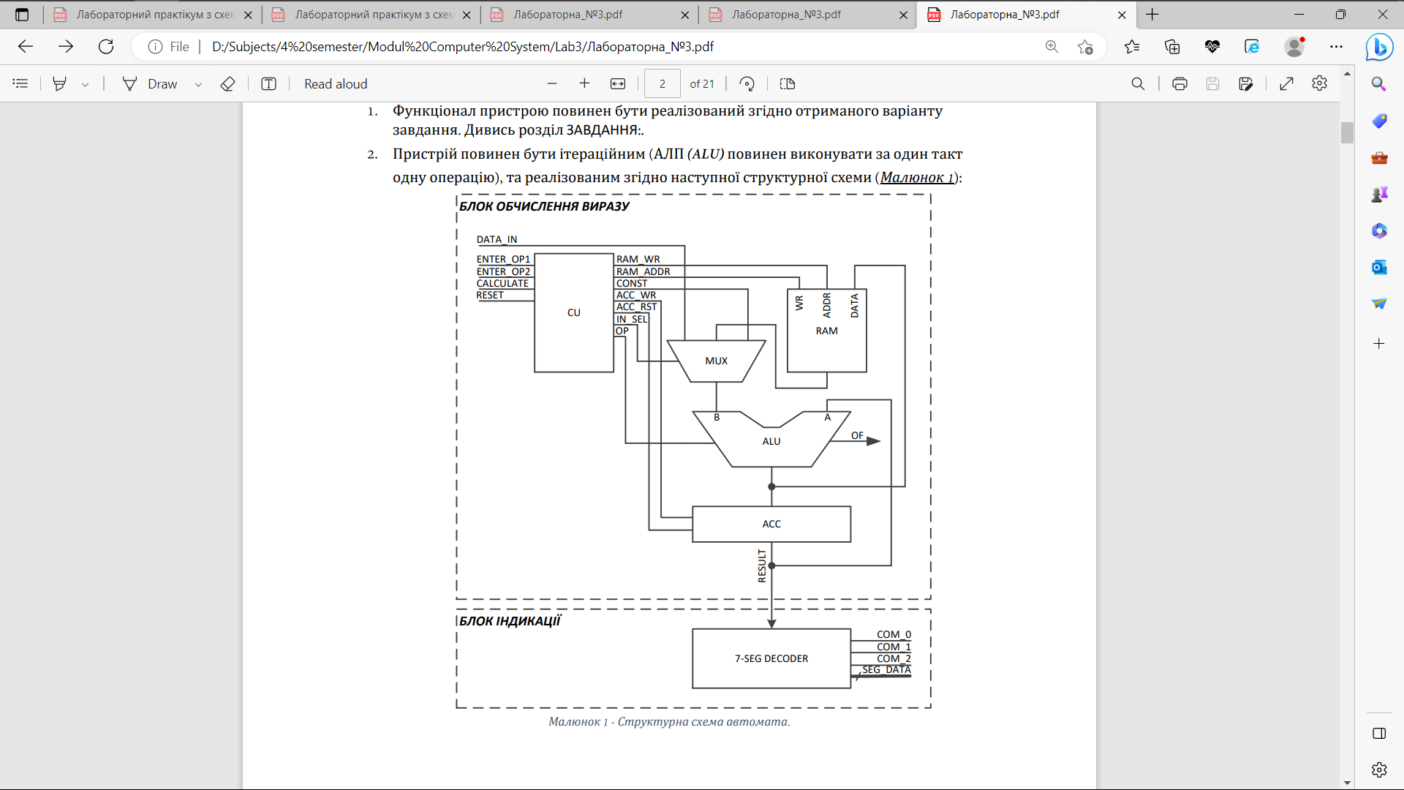

**Завдання:**





**Код на VHDL, який описує роботу ACC у файлі ACC.vhdl:**

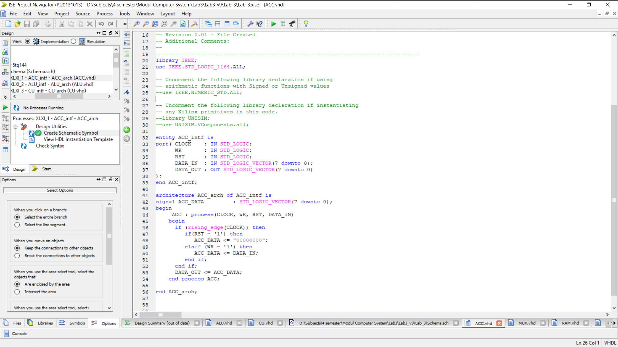

**Код на VHDL, який описує роботу ALU у файлі ALU.vhdl:**

library IEEE;

use IEEE.STD_LOGIC_1164.ALL;

use IEEE.NUMERIC_STD.ALL;

entity ALU_intf is

port (

OP_CODE_BUS : in std_logic_vector(1 downto 0);

INPUT_A : in std_logic_vector(7 downto 0);

INPUT_B : in std_logic_vector(7 downto 0);

RESULT : out std_logic_vector(7 downto 0);

OVERFLOW : out std_logic

);

end ALU_intf;

architecture ALU_arch of ALU_intf is

signal RES_ADD : unsigned(8 downto 0);

begin

ALU : process(OP_CODE_BUS, INPUT_A, INPUT_B)

variable A : unsigned(7 downto 0);

variable B : unsigned(7 downto 0);

begin

A := unsigned(INPUT_A);

B := unsigned(INPUT_B);

case OP_CODE_BUS is

when "00" =>

RESULT <= INPUT_B;

OVERFLOW <= '0';

when "01" =>

RESULT <= std_logic_vector(A - B);

if A < B then

OVERFLOW <= '1';

else

OVERFLOW <= '0';

end if;

when "10" =>

RES_ADD <= unsigned('0' & A) + unsigned('0' & B);

RESULT <= std_logic_vector(A + B);

if RES_ADD(8) = '1' then

OVERFLOW <= '1';

else

OVERFLOW <= '0';

end if;

when "11" =>

RESULT <= std_logic_vector(A or B);

OVERFLOW <= '0';

when others =>

RESULT <= (others => '0');

OVERFLOW <= '0';

end case;

end process ALU;

end ALU_arch;

**Код на VHDL, який описує роботу CU у файлі CU.vhdl:**

----------------------------------------------------------------------------------

-- Company:

-- Engineer:

--

-- Create Date: 02:54:27 06/01/2023

-- Design Name:

-- Module Name: CU_intf - CU_arch

-- Project Name:

-- Target Devices:

-- Tool versions:

-- Description:

--

-- Dependencies:

--

-- Revision:

-- Revision 0.01 - File Created

-- Additional Comments:

--

----------------------------------------------------------------------------------

library IEEE;

use IEEE.STD_LOGIC_1164.ALL;

-- Uncomment the following library declaration if using

-- arithmetic functions with Signed or Unsigned values

--use IEEE.NUMERIC_STD.ALL;

-- Uncomment the following library declaration if instantiating

-- any Xilinx primitives in this code.

--library UNISIM;

--use UNISIM.VComponents.all;

entity CU_intf is

port( CLOCK : IN std_logic;

RESET : in std_logic;

ENTER_OP1 : IN std_logic;

ENTER_OP2 : IN std_logic;

CALCULATE : IN std_logic;

RAM_WR : out std_logic;

RAM_ADDR_BUS : out std_logic_vector(1 downto 0);

CONST : out STD_LOGIC_VECTOR(7 downto 0);

ACC_WR : out std_logic;

ACC_RST : out std_logic;

IN_SEL : out std_logic_vector(1 downto 0);

OP_CODE_BUS : out STD_LOGIC_VECTOR(1 downto 0)

);

end CU_intf;

architecture CU_arch of CU_intf is

type cu_state_type is (cu_rst, cu_idle, cu_load_op1, cu_load_op2, cu_run_calc0, cu_run_calc1, cu_run_calc2, cu_run_calc3, cu_run_calc4, cu_finish);

signal cu_cur_state : cu_state_type;

signal cu_next_state : cu_state_type;

begin

CU_SYNC_PROC: process (CLOCK)

begin

if (rising_edge(CLOCK)) then

if (RESET = '1') then

cu_cur_state <= cu_rst;

else

cu_cur_state <= cu_next_state;

end if;

end if;

end process;

CUNEXT_STATE_DECODE: process (cu_cur_state, ENTER_OP1, ENTER_OP2, CALCULATE)

begin

--declare default state for next_state to avoid latches

cu_next_state <= cu_cur_state; --default is to stay in current state

--insert statements to decode next_state

--below is a simple example

case(cu_cur_state) is

when cu_rst =>

cu_next_state <= cu_idle;

when cu_idle =>

if (ENTER_OP1 = '1') then

cu_next_state <= cu_load_op1;

elsif (ENTER_OP2 = '1') then

cu_next_state <= cu_load_op2;

elsif (CALCULATE = '1') then

cu_next_state <= cu_run_calc0;

else

cu_next_state <= cu_idle;

end if;

when cu_load_op1 =>

cu_next_state <= cu_idle;

when cu_load_op2 =>

cu_next_state <= cu_idle;

when cu_run_calc0 =>

cu_next_state <= cu_run_calc1;

when cu_run_calc1 =>

cu_next_state <= cu_run_calc2;

when cu_run_calc2 =>

cu_next_state <= cu_run_calc3;

when cu_run_calc3 =>

cu_next_state <= cu_run_calc4;

when cu_run_calc4 =>

cu_next_state <= cu_finish;

when cu_finish =>

cu_next_state <= cu_finish;

when others =>

cu_next_state <= cu_idle;

end case;

end process;

CU_OUTPUT_DECODE: process (cu_cur_state)

begin

case(cu_cur_state) is

when cu_rst =>

IN_SEL <= "00";

OP_CODE_BUS <= "00";

CONST <= "00000000";

RAM_ADDR_BUS <= "00";

RAM_WR <= '0';

ACC_RST <= '1';

ACC_WR <= '0';

when cu_idle =>

IN_SEL <= "00";

OP_CODE_BUS <= "00";

CONST <= "00000000";

RAM_ADDR_BUS <= "00";

RAM_WR <= '0';

ACC_RST <= '0';

ACC_WR <= '0';

when cu_load_op1 =>

IN_SEL <= "00";

OP_CODE_BUS <= "00";

CONST <= "00000000";

RAM_ADDR_BUS <= "00";

RAM_WR <= '1';

ACC_RST <= '0';

ACC_WR <= '1';

when cu_load_op2 =>

IN_SEL <= "00";

OP_CODE_BUS <= "00";

CONST <= "00000000";

RAM_ADDR_BUS <= "01";

RAM_WR <= '1';

ACC_RST <= '0';

ACC_WR <= '1';

when cu_run_calc0 =>

IN_SEL <= "01";

OP_CODE_BUS <= "00";

CONST <= "00000000";

RAM_ADDR_BUS <= "01";

RAM_WR <= '0';

ACC_RST <= '0';

ACC_WR <= '1';

when cu_run_calc1 =>

IN_SEL <= "10";

OP_CODE_BUS <= "01";

CONST <= "00000100";

RAM_ADDR_BUS <= "01";

RAM_WR <= '0';

ACC_RST <= '0';

ACC_WR <= '1';

when cu_run_calc2 =>

IN_SEL <= "01";

OP_CODE_BUS <= "10";

CONST <= "00000000";

RAM_ADDR_BUS <= "00";

RAM_WR <= '0';

ACC_RST <= '0';

ACC_WR <= '1';

when cu_run_calc3 =>

IN_SEL <= "10";

OP_CODE_BUS <= "10";

CONST <= "00001010";

RAM_ADDR_BUS <= "00";

RAM_WR <= '0';

ACC_RST <= '0';

ACC_WR <= '1';

when cu_run_calc4 =>

IN_SEL <= "10";

OP_CODE_BUS <= "11";

CONST <= "00000010";

RAM_ADDR_BUS <= "00";

RAM_WR <= '0';

ACC_RST <= '0';

ACC_WR <= '1';

when cu_finish =>

IN_SEL <= "00";

OP_CODE_BUS <= "00";

RAM_ADDR_BUS <= "00";

RAM_WR <= '0';

ACC_RST <= '0';

ACC_WR <= '0';

when others =>

IN_SEL <= "00";

OP_CODE_BUS <= "00";

RAM_ADDR_BUS <= "00";

RAM_WR <= '0';

ACC_RST <= '0';

ACC_WR <= '0';

end case;

end process;

end CU_arch;

**Код на VHDL, який описує роботу MUX у файлі MUX.vhdl:**

library IEEE;

use IEEE.STD_LOGIC_1164.ALL;

-- Uncomment the following library declaration if using

-- arithmetic functions with Signed or Unsigned values

--use IEEE.NUMERIC_STD.ALL;

-- Uncomment the following library declaration if instantiating

-- any Xilinx primitives in this code.

--library UNISIM;

--use UNISIM.VComponents.all;

entity MUX_intf is

port (

S : in std_logic_vector(1 downto 0);

X0, X1, CONST: in std_logic_vector(7 downto 0);

O : out std_logic_vector(7 downto 0));

end MUX_intf;

architecture MUX_arch of MUX_intf is

begin

INSEL_A_MUX : process(X0, X1, CONST, S)

begin

if( S = "00") then

O <= X0 ;

elsif(S = "01") then

O <= X1;

else

O <= CONST;

end if;

end process INSEL_A_MUX;

end MUX_arch;

**Код на VHDL, який описує роботу** RAM **у файлі** RAM**.vhdl:**

library IEEE;

use IEEE.STD_LOGIC_1164.ALL;

use IEEE.NUMERIC_STD.ALL;

use IEEE.STD_LOGIC_UNSIGNED.ALL;

-- Uncomment the following library declaration if using

-- arithmetic functions with Signed or Unsigned values

--use IEEE.NUMERIC_STD.ALL;

-- Uncomment the following library declaration if instantiating

-- any Xilinx primitives in this code.

--library UNISIM;

--use UNISIM.VComponents.all;

entity RAM_intf is

port(CLOCK : IN STD_LOGIC;

WR : in std_logic;

ADDR : IN STD_LOGIC_VECTOR(1 downto 0);

DATA_IN : IN STD_LOGIC_VECTOR(7 downto 0);

DATA_OUT : OUT STD_LOGIC_VECTOR(7 downto 0));

end RAM_intf;

architecture RAM_arch of RAM_intf is

type ram_type is array (3 downto 0) of STD_LOGIC_VECTOR(7 downto 0);

signal RAM_UNIT : ram_type;

begin

RAM : process(CLOCK, ADDR, RAM_UNIT, WR , DATA_IN)

begin

if (rising_edge(CLOCK)) then

if (WR = '1') then

RAM_UNIT(conv_integer(ADDR)) <= DATA_IN;

end if;

end if;

DATA_OUT<= RAM_UNIT(conv_integer(ADDR));

end process RAM;

end RAM_arch;

**Код на VHDL, який описує роботу RES_DECODER у файлі RES_DECODER.vhdl:**

library IEEE;

use IEEE.STD_LOGIC_1164.ALL;

use IEEE.STD_LOGIC_UNSIGNED.ALL;

use IEEE.STD_LOGIC_ARITH.ALL;

entity RES_DECODER_intf is

port (

CLOCK : in STD_LOGIC;

INPUT_NUM : in STD_LOGIC_VECTOR(7 downto 0);

RESET : in STD_LOGIC;

COMM_ONES : OUT STD_LOGIC;

COMM_DECS : OUT STD_LOGIC;

COMM_HUNDREDS : OUT STD_LOGIC;

SEG_A : OUT STD_LOGIC;

SEG_B : OUT STD_LOGIC;

SEG_C : OUT STD_LOGIC;

SEG_D : OUT STD_LOGIC;

SEG_E : OUT STD_LOGIC;

SEG_F : OUT STD_LOGIC;

SEG_G : OUT STD_LOGIC;

DP : OUT STD_LOGIC

);

end RES_DECODER_intf;

architecture RES_DECODER_arch of RES_DECODER_intf is

signal ONES_BUS : STD_LOGIC_VECTOR(3 downto 0) := "0000";

signal DECS_BUS : STD_LOGIC_VECTOR(3 downto 0) := "0001";

signal HONDREDS_BUS : STD_LOGIC_VECTOR(3 downto 0) := "0000";

begin

BIN_TO_BCD : process (INPUT_NUM)

variable hex_src : STD_LOGIC_VECTOR(7 downto 0) ;

variable bcd : STD_LOGIC_VECTOR(11 downto 0) ;

begin

bcd := (others => '0') ;

hex_src := INPUT_NUM;

for i in hex_src'range loop

if bcd(3 downto 0) > "0100" then

bcd(3 downto 0) := bcd(3 downto 0) + "0011" ;

end if ;

if bcd(7 downto 4) > "0100" then

bcd(7 downto 4) := bcd(7 downto 4) + "0011" ;

end if ;

if bcd(11 downto 8) > "0100" then

bcd(11 downto 8) := bcd(11 downto 8) + "0011" ;

end if ;

bcd := bcd(10 downto 0) & hex_src(hex_src'left) ; -- shift bcd + 1 new entry

hex_src := hex_src(hex_src'left - 1 downto hex_src'right) & '0' ; -- shift src + pad with 0

end loop ;

HONDREDS_BUS <= bcd (11 downto 8);

DECS_BUS <= bcd (7 downto 4);

ONES_BUS <= bcd (3 downto 0);

end process BIN_TO_BCD;

INDICATE : process(CLOCK)

type DIGIT_TYPE is (ONES, DECS, HUNDREDS);

variable CUR_DIGIT : DIGIT_TYPE := ONES;

variable DIGIT_VAL : STD_LOGIC_VECTOR(3 downto 0) := "0000";

variable DIGIT_CTRL : STD_LOGIC_VECTOR(6 downto 0) := "0000000";

variable COMMONS_CTRL : STD_LOGIC_VECTOR(2 downto 0) := "000";

begin

if (rising_edge(CLOCK)) then

if(RESET = '0') then

case CUR_DIGIT is

when ONES =>

DIGIT_VAL := ONES_BUS;

CUR_DIGIT := DECS;

COMMONS_CTRL := "001";

when DECS =>

DIGIT_VAL := DECS_BUS;

CUR_DIGIT := HUNDREDS;

COMMONS_CTRL := "010";

when HUNDREDS =>

DIGIT_VAL := HONDREDS_BUS;

CUR_DIGIT := ONES;

COMMONS_CTRL := "100";

when others =>

DIGIT_VAL := ONES_BUS;

CUR_DIGIT := ONES;

COMMONS_CTRL := "000";

end case;

case DIGIT_VAL is --abcdefg

when "0000" => DIGIT_CTRL := "1111110";

when "0001" => DIGIT_CTRL := "0110000";

when "0010" => DIGIT_CTRL := "1101101";

when "0011" => DIGIT_CTRL := "1111001";

when "0100" => DIGIT_CTRL := "0110011";

when "0101" => DIGIT_CTRL := "1011011";

when "0110" => DIGIT_CTRL := "1011111";

when "0111" => DIGIT_CTRL := "1110000";

when "1000" => DIGIT_CTRL := "1111111";

when "1001" => DIGIT_CTRL := "1111011";

when others => DIGIT_CTRL := "0000000";

end case;

else

DIGIT_VAL := ONES_BUS;

CUR_DIGIT := ONES;

COMMONS_CTRL := "000";

end if;

COMM_ONES <= COMMONS_CTRL(0);

COMM_DECS <= COMMONS_CTRL(1);

COMM_HUNDREDS <= COMMONS_CTRL(2);

SEG_A <= DIGIT_CTRL(6);

SEG_B <= DIGIT_CTRL(5);

SEG_C <= DIGIT_CTRL(4);

SEG_D <= DIGIT_CTRL(3);

SEG_E <= DIGIT_CTRL(2);

SEG_F <= DIGIT_CTRL(1);

SEG_G <= DIGIT_CTRL(0);

DP <= '0';

end if;

end process INDICATE;

end RES_DECODER_arch;

**Constrain для моделювання на стенді:**

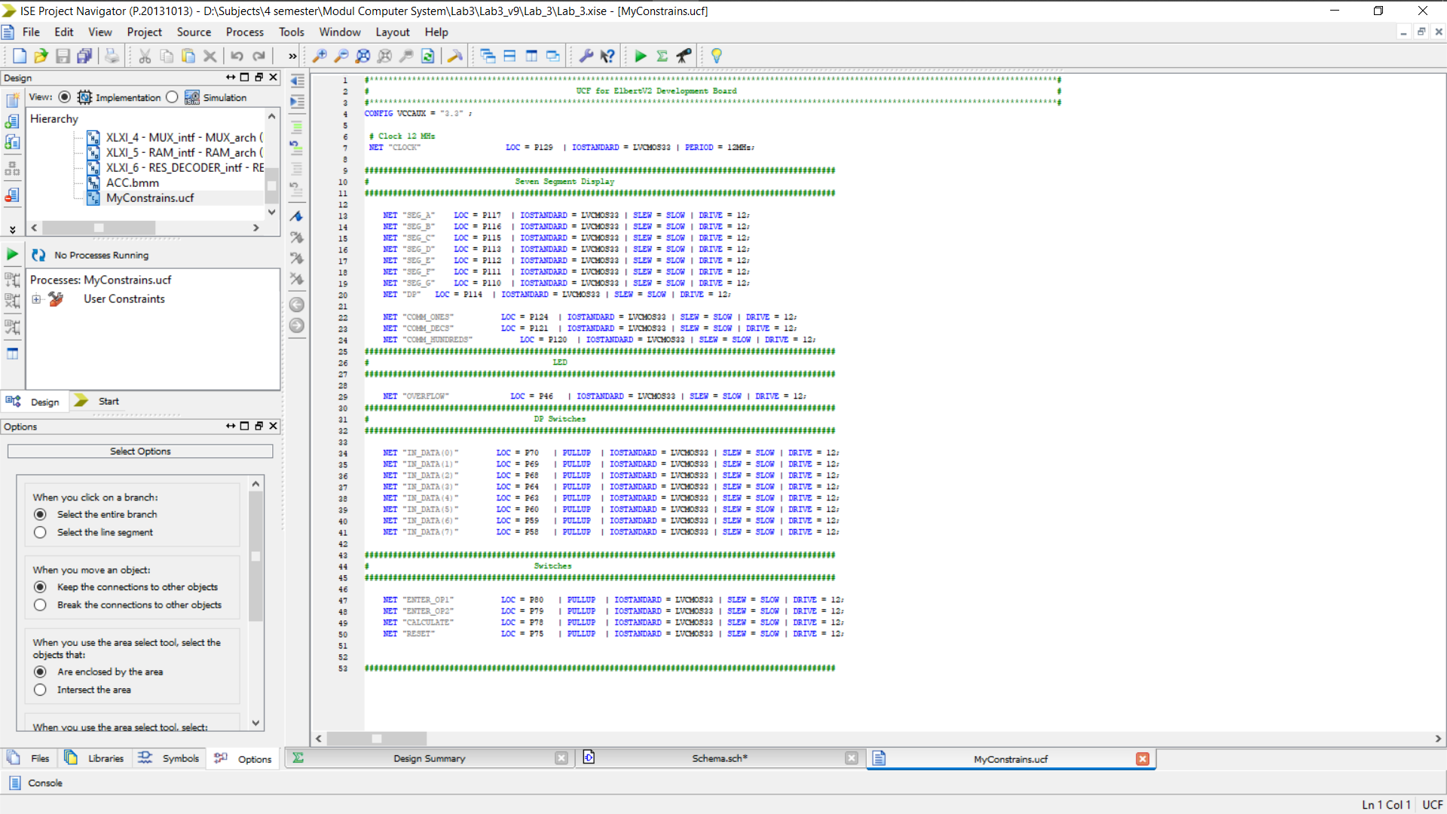

**Схема пристрою:**

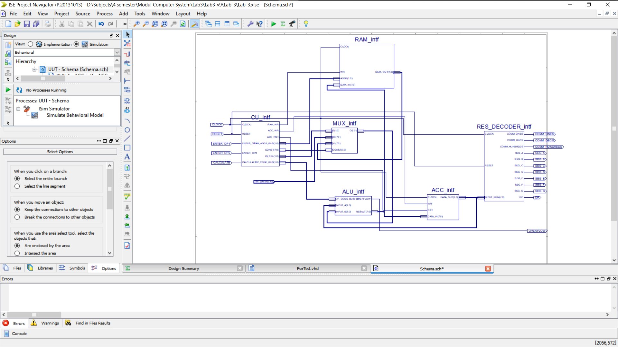

**Результат перевірки роботи схеми за допомогою симулятора ISim**:

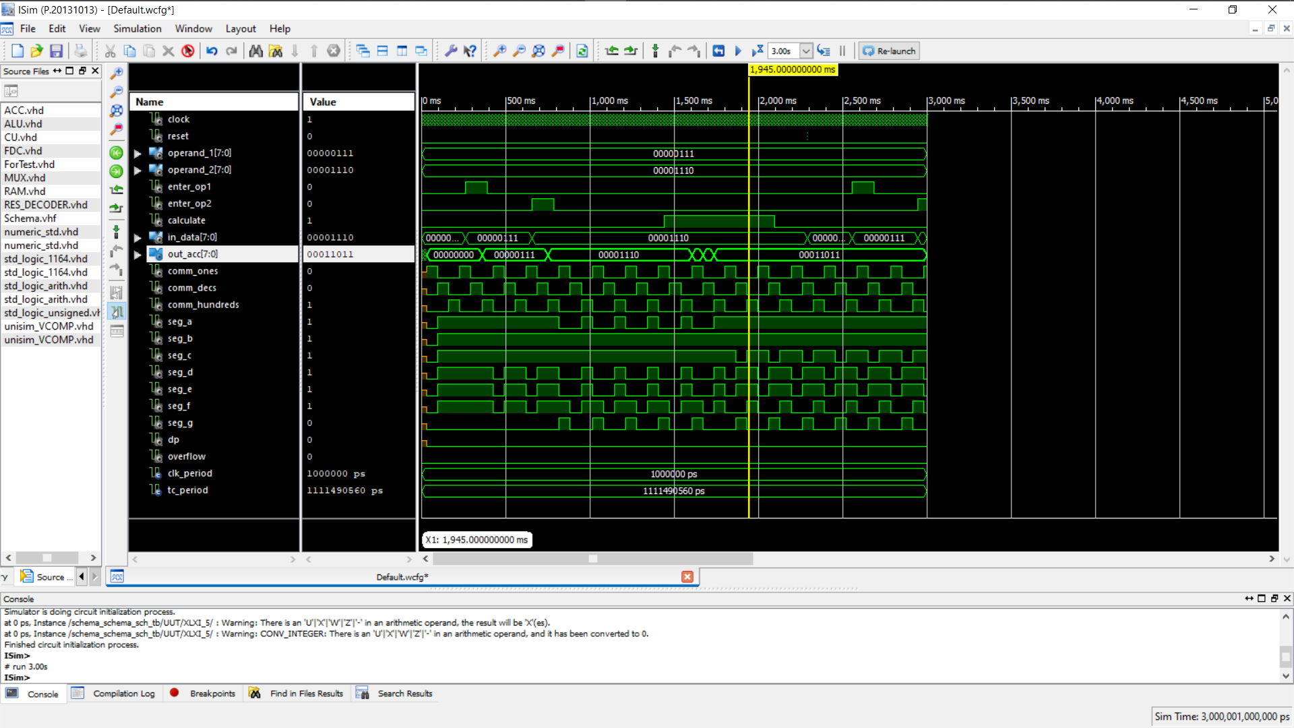

**Висновок:** Я на базі стенда реалізував ітераційний цифровий автомат для обчислення значення виразу згідно варіанту завдання та структурної схеми автомату.